16.70: (See Problems 16.66, 16.74, 16.67). a) In a time t, the wall has moved a distance 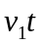 and the wavefront that hits the wall at time t has traveled a distance vt, where 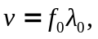 and the number of wavecrests in the total distance is 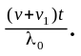 b) The reflected wave has traveled vt and the wall has moved 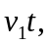so the wall and the wavefront are separated by 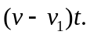 c) The distance found in part (b) must contain the number of reflected waves found in part (a), and the ratio of the quantities is the wavelength of the reflected wave, 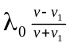. d) The speed v divided by the result of part (c), expressed in terms of 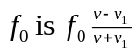. This is what is predicted by the problem-solving strategy. 